OCTOBER BLOCK

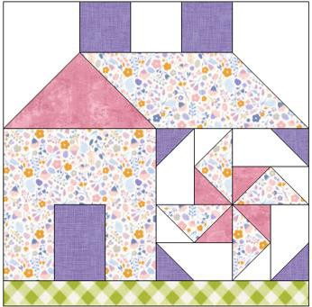Finish block 12” square Please read all instructions before cutting and sewing.

|  |  |  |  |
| --- | --- | --- | --- |
| Cutting Instructions | | | |
| Fabric | Size | Cu  t |  |
| Background | 3 ½" x 2 ½" rectangles | 2 | A |
|  | 2 ½" square | 1 | B |
|  | 3 ½" x 3 ½" squares | 2 | C |
| Purple | 2 ½" square | 2 | D |
|  | 3 ½" x 2 ½" rectangle | 1 | E |
| Print | 3 ½" x 6 ½" rectangles | 2 | F |
|  | 3 ½" square | 1 | G |
|  | 3 ½" x 2 ½" rectangles | 2 | H |
| Pink | 3 ½" x 6 ½" rectangle | 1 | I |
| Green | 1 ½" x 12 ½" rectangle | 1 | J |

Sewing Instructions All seam allowances are ¼ inch.

1. Sew Fabrics A – D – B – D – A. Finished unit should measure 2 ½” x 12 ½”.



1. Make Flying geese with Fabrics C – I – G. Draw a diagonal line on the wrong side of Fabrics C and G squares. With right side facing, layer Fabric C square on left side of Fabric I. Sew on the drawn line and trim ¼” away from the seam. Repeat on the right side with Fabric G square. The Flying geese should measure 3 ½”x 6 ½”.

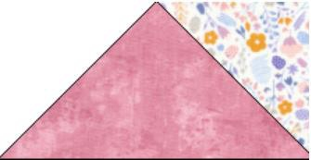

1. Draw a diagonal line on the wrong side of Fabric C. With right side facing, layer Fabric C square on right side of Fabric

F. Sew on the drawn line and trim ¼” away from the seam. Unit should measure 3 ½”x 6 ½”.

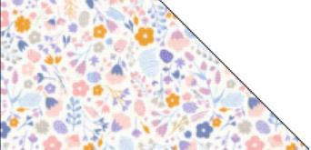

1. Sew Fabrics H - E - H. Finished unit should measure 3 ½”x 6 ½”.

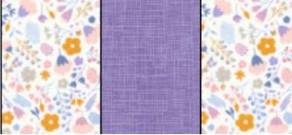

Then sew one Fabric F on the top. Finished unit should measure 6 ½” x 6 ½”.

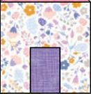

1. **Block** 6” x 6” (6 ½” x 6½” unfinished)

|  |  |  |  |
| --- | --- | --- | --- |
| Cutting Instructions | | | |
| Fabric | Size | Cut |  |
| Background | 3½” x 2” rectangles | 4 | AA |
| Background | 2” squares | 4 | BB |
| Purple | 2” squares | 4 | CC |
| Print | 3½” x 2” rectangles | 4 | DD |
| Pink | 2” squares | 4 | EE |

Draw a diagonal line on the wrong side of the BB, CC, and DD squares. With right sides together, place a CC fabric on the right side of one AA fabric. Sew on the drawn line and press. Repeat steps to make 4 units. Units should be 3½” x 2” rectangles.



With right sides together, place a BB fabric on the right side of one DD fabric. Sew on the drawn line and press. Then place a EE fabric on the left side. Repeat steps to make 4 sets. Units should be 3½” x 2” rectangles.

Assemble unit as shown below. Unit should measure 6 ½”x 6 ½”.

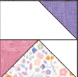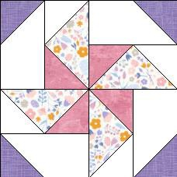

1. Assemble block. Unfinished block should measure 12 ½”x 12 ½”.

